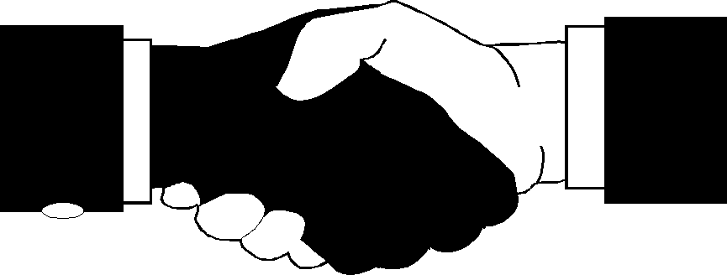 ICUA OF VIRGINIA Newsletter

April 10, 2012

Greetings:

To: All Fellow Ushers

Please support the upcoming ICUA 56th State Convention . My last year as president will end in May 19, 2012. I would like to thank all of my fellow ushers for your support for the past four years.

All officers are asked to plan to be in attendance at our annual state convention. Continue to lift the ICUA of VA lifted up in prayer along with our sick and shut in.

Gloria Greenhow
State President



56th State Convention

Host District #6
May 18 & 19, 2012
Mount Ararat Christian Church
1860 Airport Road
Suffolk, Virginia 23434

KING AND QUEEN Pageant

Please support the King & Queen progam .
Mt. Ararat
Christian Church
May 18, 2012 at
7:00 P.M. .

CHAIRPERSON
Berthel Watkins
HOTEL INFORMAATION

Hilton Garden Inn (Suffolk Conference Center) 100 East Constance Rd Suffolk, VA 757 925-1300 Rooms were $90.00 plus 8% city tax and 5% tax a night Deadline for reservations will be April 18, 2012.

FAREWELL luncheon

A farewell Luncheon for Shirley McWilliams Past president of the ICUA of VA will take place on Saturday, May 19, 2012. Ticket information and cost will be provided at a later date.
Sister McWilliams will be relocating to Louisiana and be a part of the Sothern Region.

ICUA OF VA Newsletter
2012 State Convention Souvenir Journal

Be a part of this year’s souvenir journal by placing an ad or greeting,
business card .
The prices for ads are:
Full page - $40
Half page - $25
Quarter page - $15
Business card - $10

Deadline to submit ads is May 5, 2012
Send ad and check payable to ICUA of VA, Inc. to:

Souvenir Journal Chairperson Donna Scruggs
3674 Golf Side Circle #301
Woodbridge, VA 22192
fannieboo@msn.com

Nominating Committee

The Following Positions are available for election at the state convention;

President
Recording Secretary
Assistant Recording Secretary

Board of Directors:
3 positions

Please send all resume’s to :
Nominatiing Chairperson
Latachia Lewis,
1594 Brooke Road
Stafford, VA 22554
Deadline April 30, 2012.
Email: Latachia Lewis latachia.lewis@vdh.virginia.gov

Outreach

Please support the outreach project.

A donation will be given to the American Red Cross for the the purchase of First Aid Kits.
(Please see attached Patron List.)

